Dear Family,

This year, our class has been using many educational resources from HeidiSongs.com. In fact, if your child has been coming home singing spelling songs to you, they probably came from HeidiSongs.com! HeidiSongs is a great resource for educational products that children enjoy, so be sure to check out this website for CDs, DVDs, worksheets, and other products to help your child learn at home, especially during holidays and vacations.
Below are the items I recommend for the children in our class to help them continue learning over the summer:

______________________

______________________

Thank you, and have a happy summer!

Your Child's Teacher
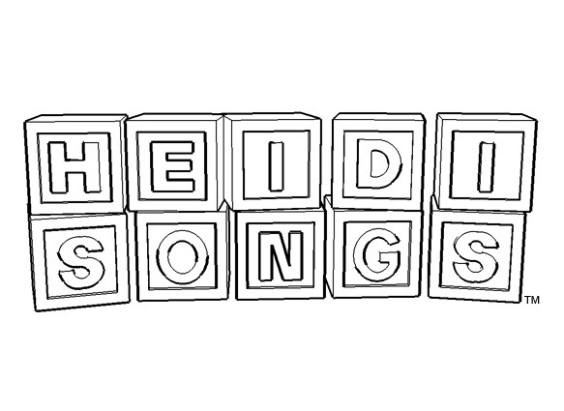
Here is a sample of some of the products Heidi Songs has to offer. You can find the complete product line as well as view video clips at heidisongs.com

☐ Preschool Classroom Combo
☐ Kindergarten Classroom Combo
☐ First Classroom Combo
☐ Numbers and Shapes
☐ Jumpin’ Numbers and Shakin’ Shapes Vol 1 and 2 DVD and CD
☐ Counting Creatures 1-10 Number Workbook
☐ Counting Creatures 11-20 Number Workbook
☐ Jumpin’ Numbers Songbook and Flashcards
☐ Musical Math DVD and CD
☐ Musical Math Vol 2 DVD and CD
☐ Number Jumble 0-30 DVD
☐ Phonics
☐ Sounds Fun Phonics DVD and CD
☐ Sounds Fun Phonics Flash Cards
☐ Sounds Fun Phonics Workbook 1 and 2
- Word Family Songs
☐ Word Family Songs DVD and CD
☐ CVC Workbooks Volume 1 and 2
☐ Sight Words
☐ Sing and Spell Volumes 1 through 6, Classic or Animated
☐ Letters and Sounds
☐ Letters and Sounds DVD and CD
☐ Alphabet Workbook Volume 1 and 2
☐ Songbook, Flashcards and Bingo for Singable Songs for Letters and Sounds
☐ Language Arts
☐ Little Songs for Language Arts DVD and CD
☐ Little Songs for Language Arts Singable Books and Printable Projects
☐ Storybooks and Read-Alouds
☐ Opposites Rhyming Picture Book
☐ Alphabet Action Picture Book
☐ The 1 to 100 Counting Picture Book
☐ Colors and Shapes
☐ Colors and Shapes DVD
☐ Color Song Projects
- Shape Song Projects

